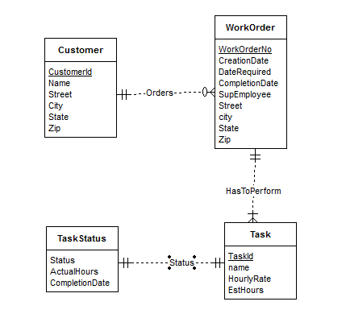

Each Work order has one customer although a customer may specify multiple work orders so I used a M-1 relationship to connect Work Orders to customers. Since a single WorkOrder may have many tasks I used a M-1 relationship from Task to Work Order entities.

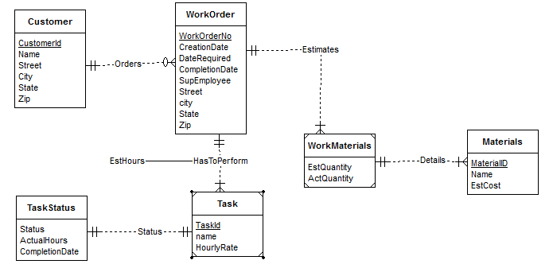

The additional entity, Materials has been added which connects to Work Orders .

Because the estimated number of hours for a task depends both on the work order and task, I change the relationship “Performed” connecting Task and Work Orders to include the attribute of ‘Est Hours’.